# ****Deploying a Python HELLO WORLD program with Jenkins on AWS EC2****

Deploying a Python HELLO WORLD program using Jenkins on an AWS EC2 instance involves integrating Jenkins with Docker. This automates the build and deployment processes, enabling efficient continuous integration and continuous delivery (CI/CD) pipelines.

****Launch an EC2 Instance on AWS****

* Create an EC2 instance on AWS with Ubuntu 22.04.
* T2.Micro with 8 GB storage.

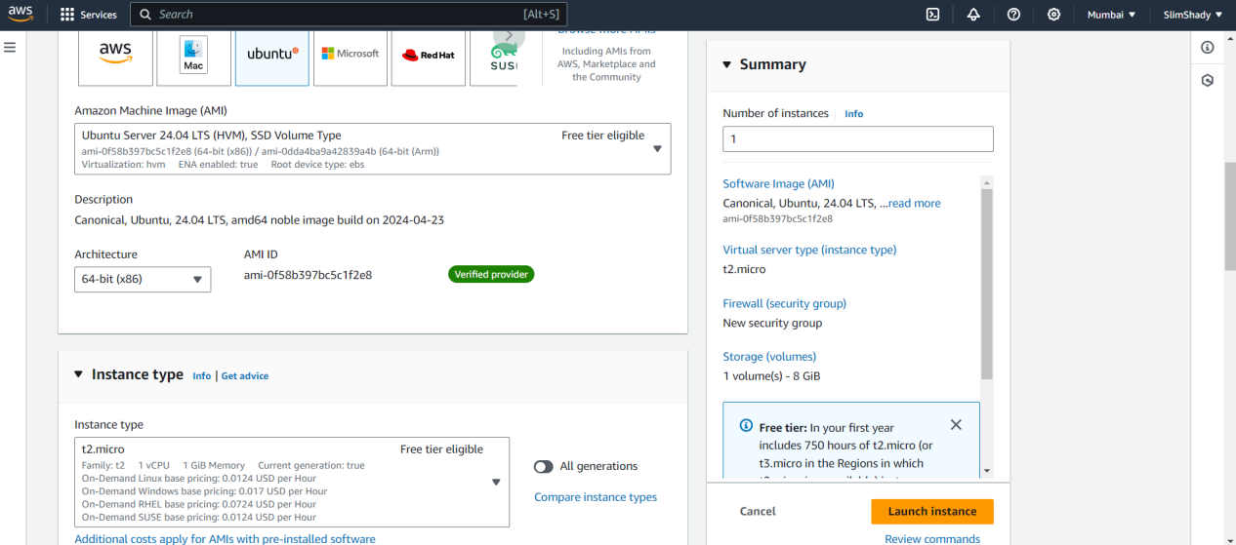

* Connect to the instance using SSH.

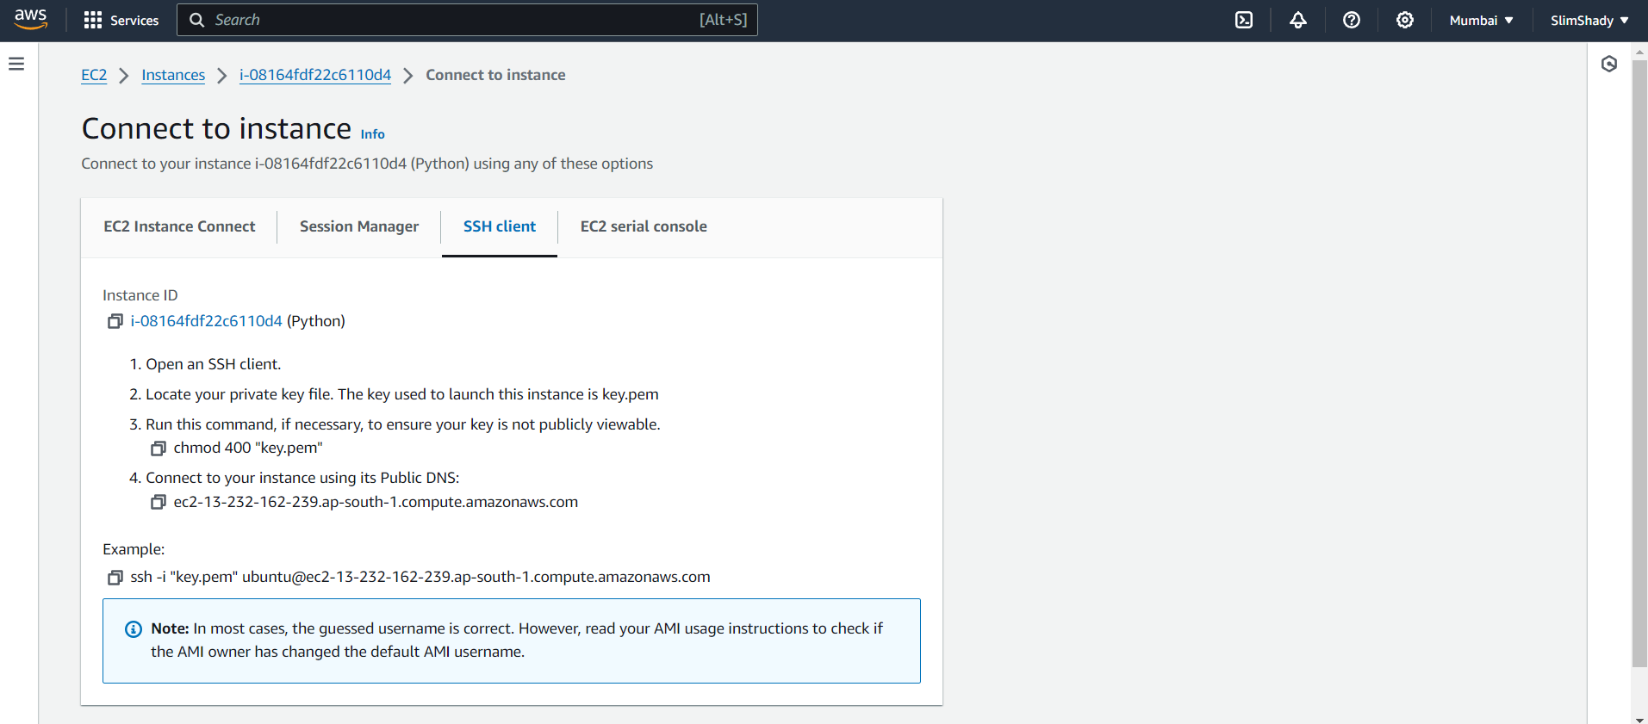

****Install Java,Jenkins,Docker****

****Setup Java on EC2 Instance:****

sudo apt update  
sudo apt install openjdk-11-jre-headless  
java --version

****Setup Jenkins on EC2 Instance:****

sudo apt update  
sudo wget -O /usr/share/keyrings/jenkins-keyring.asc \  
https://pkg.jenkins.io/debian-stable/jenkins.io-2023.key  
echo deb [signed-by=/usr/share/keyrings/jenkins-keyring.asc] \  
https://pkg.jenkins.io/debian-stable binary/ | sudo tee \  
/etc/apt/sources.list.d/jenkins.list > /dev/null  
sudo apt-get update  
sudo apt-get install jenkins -y  
sudo systemctl enable jenkins  
sudo systemctl start jenkins  
sudo systemctl status jenkins  
sudo usermod -aG jenkins ubuntu

****Setup Docker on EC2 Instance:****

sudo apt install docker.io -y  
sudo usermod -aG docker ubuntu  
newgrp docker  
sudo chmod 666 /var/run/docker.sock  
docker info

****Setup Jenkins Dashboard****

* After installing Jenkins, you’ll need to unlock it by retrieving the initial administrative password.
* The Administrator password is stored in a file called initialAdminPassword.

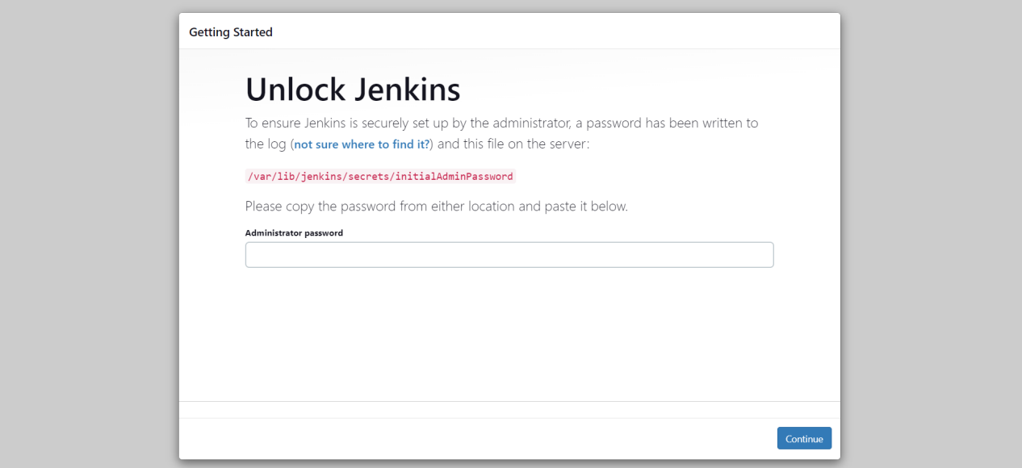

* Use the following command to view the Administrator password.

sudo cat /var/lib/jenkins/secrets/initialAdminPassword

* Login to the Jenkins Dashboard and install suggested plugins.

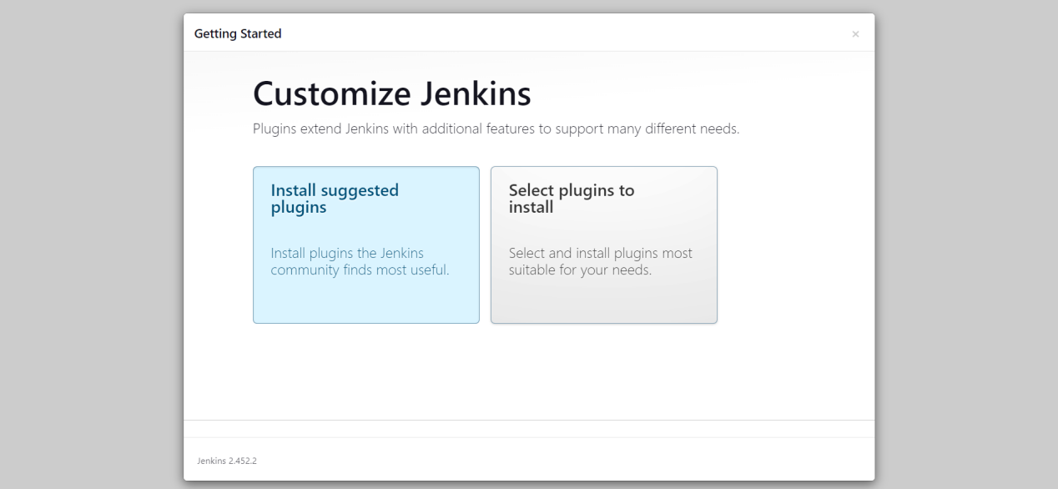

* Install the following plugins (Go to Manage Jenkins → Manage Plugins → Available)
* Docker Pipeline
* Docker Plugin
* docker-build-step

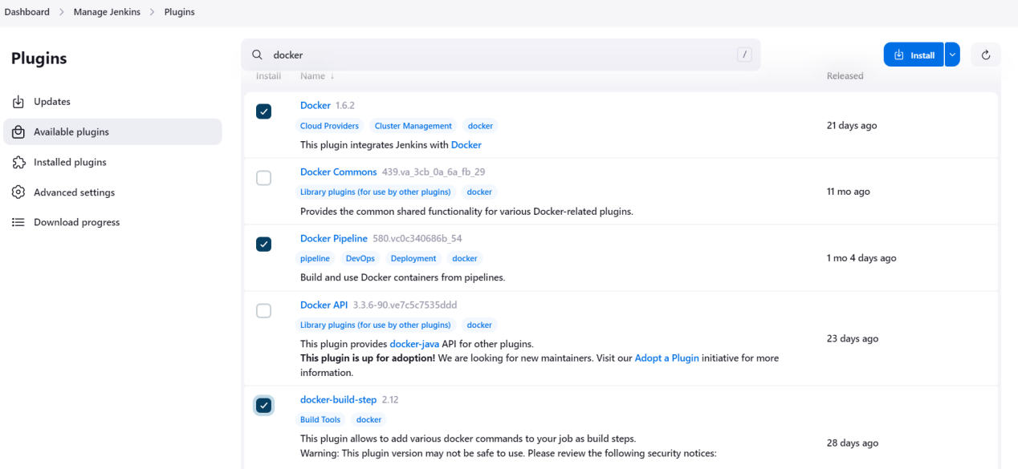

****Create Jenkins Pipeline****

* In the Jenkins dashboard, click “New Item.”

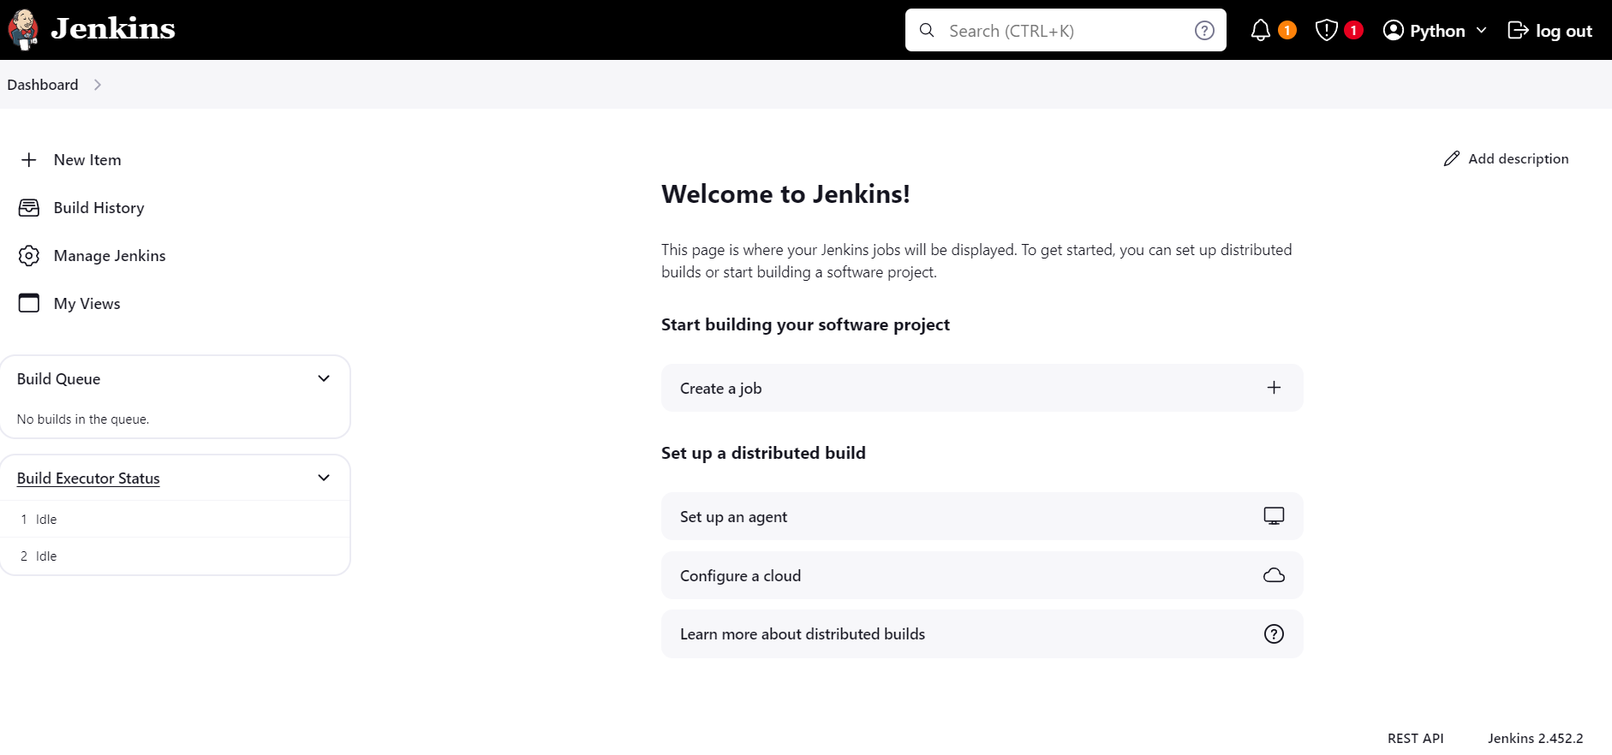

* Enter a name for your item and select “Pipeline.”

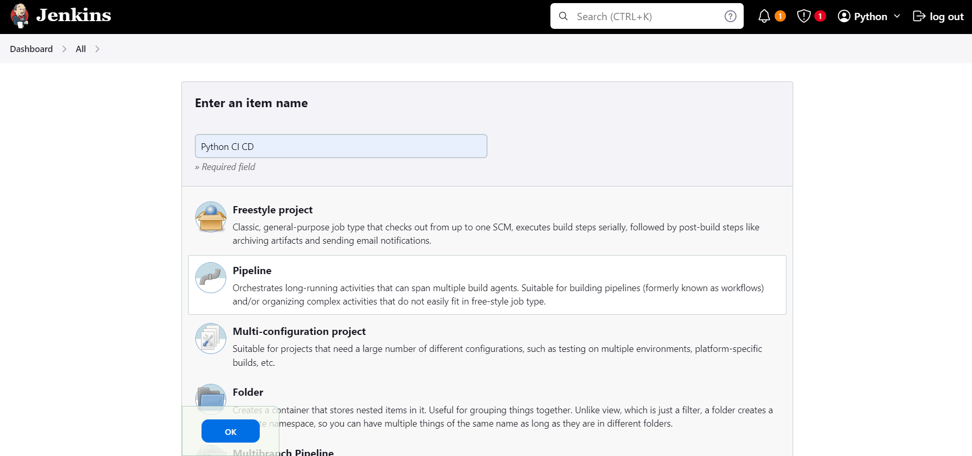

* Press “OK.”
* Use the following pipeline script:

pipeline

{

agent any

stages

{

stage('Python Version ') {

steps {

sh "sudo -S apt update"

sh "sudo apt install python3-venv -y"

sh "python3 --version"

}

}

stage('Docker Version') {

steps {

sh "docker -v"

}

}

stage('Git Checkout') {

steps {

checkout scmGit(branches: [[name: '*/master']], extensions: [], userRemoteConfigs: [[url: 'https://github.com/TholadaChaitanya/Assignment.git']])

}

}

stage('Docker Build') {

steps {

sh "sudo docker build -t assignment ."

}

}

stage('Docker Run')

{

steps

{

script

{

sh "echo Chaitu@123 | sudo docker login -u chaitanyatholada --password-stdin"

sh "sudo docker run -d -p 5000:5000 assignment"

}

}

}

}

}

****Trigger the Build****

* After applying your script, go to your Jenkins project.

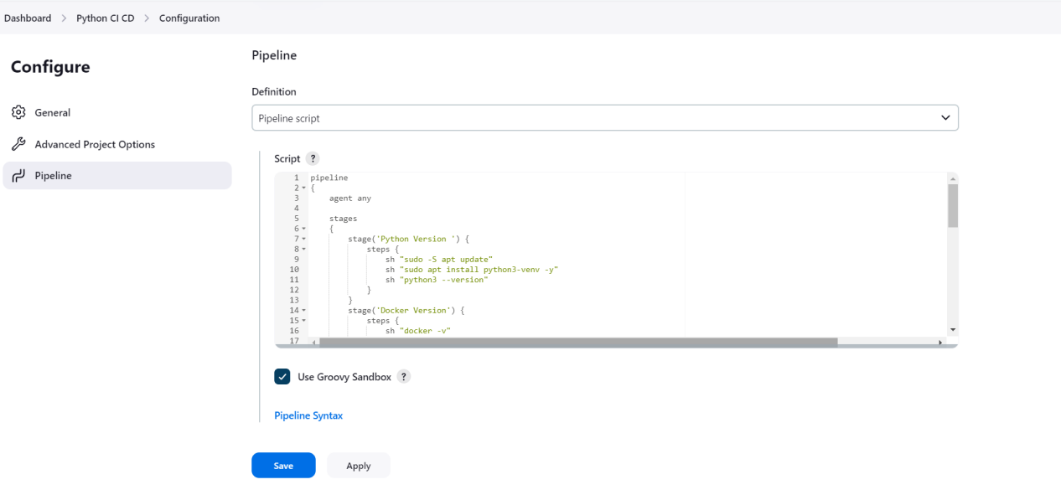

* Click on “Build Now.”

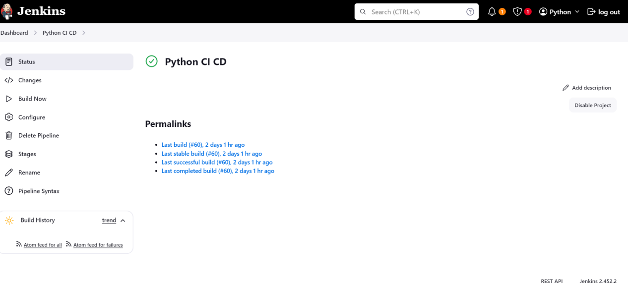

* The build will be scheduled and executed.

****Stage View****

* After the build completes successfully, you can see the stage view of all the steps.
* This view provides a visual representation of each stage in your pipeline.

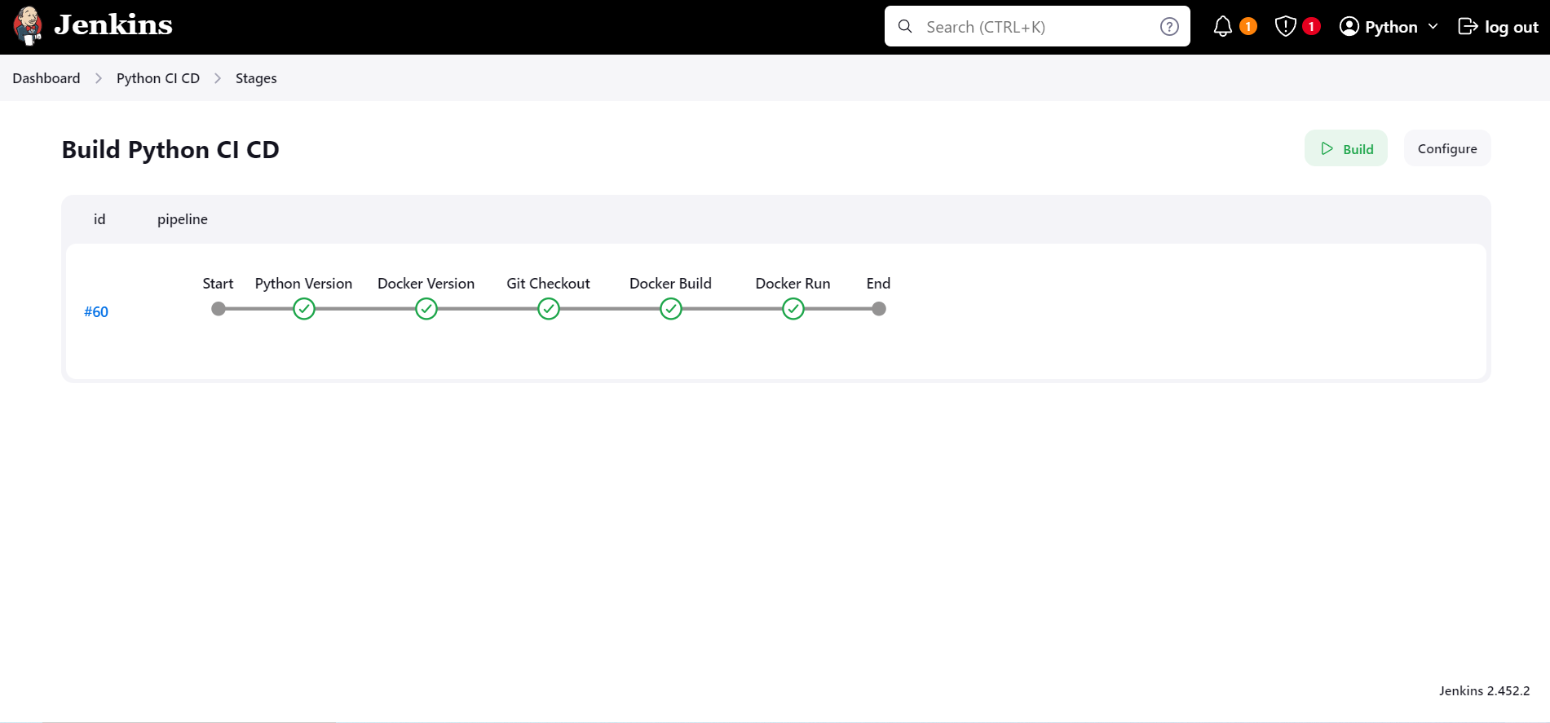

****OUTPUT:****

****